Since the technology and design of EVs is still developing, no common standards in EV battery design have yet been established. Consequently, many design variations exist. One reason for this is that most car manufacturers only make small changes to their conventional cars in order to make them electrically driven. This means that the battery is designed to fit in an already-existing car body and not vice versa. Therefore, the design of EV batteries differs not only from manufacturer to manufacturer, but also from car model to car model.

basic steps that are required for the disassembly of a battery system. These are:

1. Opening of the battery system, i.e. removal of the cover

2. Cutting of the electrical connections between the battery modules and the electronic components

3. Removal of the mechanical connections between the system components (modules, electronics) and the battery base

4. Removal of the electronic components

5. Removal of the battery modules

6. Disassembly of the battery modules and removal of the battery cells

The handling operations, in particular the separation of components, often require high manoeuvrability and varying forces and techniques. Since the required techniques are highly dependent on the design of the product, the automation of these tasks was deemed to be prohibitively difficult and costly. On the other hand, screws and bolts are standardised components and can be removed using the same technique. Unscrewing is a relatively simple technique that has been automated previously and has widespread application in the disassembly of EV batteries. Hence, it seems worthwhile to implement the task of unscrewing on a robot that assists a human worker.

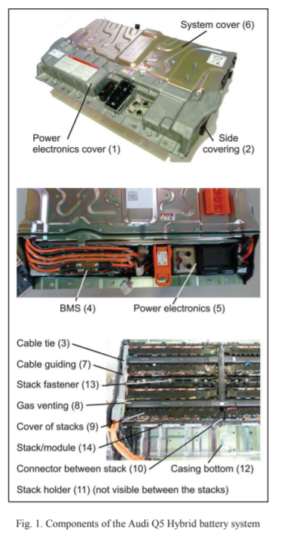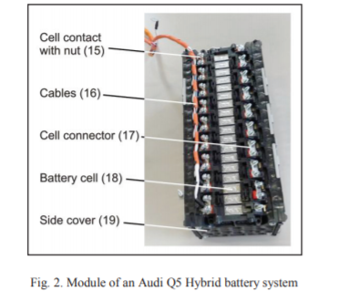

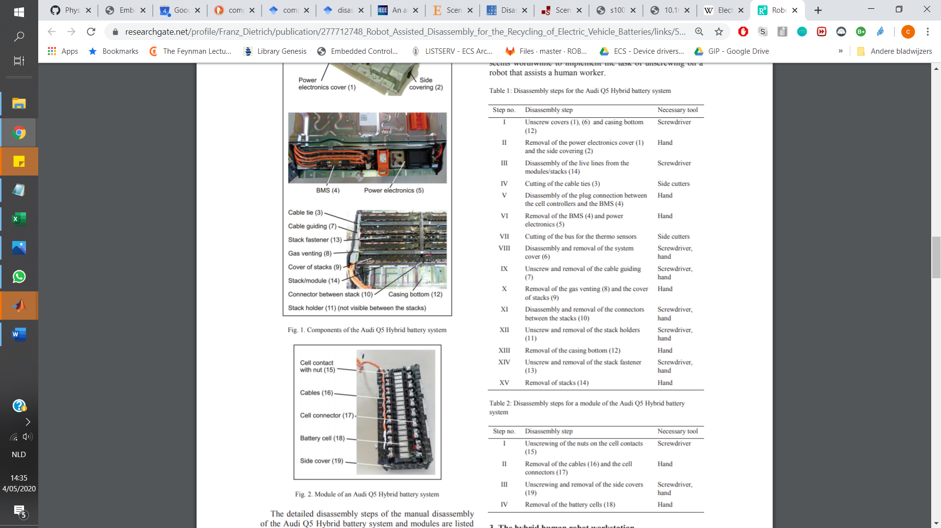

human and robot also require access to their own disassembly tools. For the human this may be a variety of tools including pliers, screwdrivers, a hammer and cutting tools. For the robot this consists of different kinds of socket wrench bits for its unscrewing tool (not depicted in the figure). The human carries out more complex tasks such as prying apart components joined with snap fits or (to a limited extent) glue, and pulling out or cutting cables, while the robot unfastens all screws and bolts. The location of the screws and bolts can be either taught manually or detected via a camera. In the figure this is indicated by a sketch of a camera with its field of view on the battery.

n order to perform this task, the robot must first know the location of the screw to be removed. Since detailed product specifications are generally not available to the recycler, it is impractical to assume that exact locations will be available via a database or CAD models. Hence, it is desirable to acquire the locations of fasteners at the point of disassembly. Unskilled workers are generally employed for disassembly to minimise costs. Therefore, only methods that do not require high technical expertise of operators can be considered. Two potential methods of acquiring this information are: 1. User demonstration: users intuitively add to the system’s knowledge or database by physically demonstrating this knowledge on the product at hand. 2. Detection: the system identifies and localises fasteners autonomously using cameras or similar technology. In this case, a significantly higher rate of errors is expected.

The main drawback in using physical demonstration to teach the location of each fastener is the time required for the human to correctly position the robot. On the other hand, physical demonstration is also useful for teaching the robot appropriate joint configurations.

4.3. Camera-based detection of screws The approach used by [6, 7] was trialled for the camerabased detection of screws, since the Haar Cascade implementation is open source and freely accessible in the OpenCV library (available at http://opencv.org/). We hypothesised that the reported false positive rate could be improved by x Using higher resolution in the positive training set, and x Using images from disassembly (particularly examples of false positives) in the negative training set. A Haar Cascade was trained on a training set consisting of manually-cropped images of the M5 bolts on the contacts of the Q5 battery module

Paper:

**Assessment of Automation Potentials for the Disassembly of Automotive Lithium Ion Battery Systems**

Based on these findings a possible disassembly system may be divided into the following parts:

• discharge of the battery system before the dismantling process,

• manual dismantling of the system down to module level,

• automatic extraction of the modules from the system,

• manual dismantling of the module to expose the battery cells,

• automatic removal of the cells from the modules,

• discharge of the battery cells for further processing. Depending on the design of the battery systems, it can be even possible to automate some of the system and module disassembly processes.

Based on the disassembly step C ‘extraction of a single lithium cell’ a gripping device has been developed to accomplish this task [35]. The gripper system, as depicted in Figure 7, is designed for gripping pouch cells at the contacts with a pneumatic two-finger parallel gripper. One of the grippers is stationary while the second one can be moved into the necessary position to safely grip the battery cell. The grippers can be easily adapted to another battery cell type by exchanging the gripper jaws. These jaws contain contacts to measure the voltage of the selected cell, while removing it from the module. With this measured voltage the internal resistance of the battery cell can be determined, which allows an inference on the state of the cell. The whole gripper system can be mounted to a SCARA robot to carry out the disassembly actions.

Paper: **End-of-life (EOL) issues and options for electric vehicle batteries**

EV battery made with LiFePO4 cathode will dominate market for automotive applications. Pollet et al. (2012) indicated that the majority of EV manufacturers have avoided the use of lithiumcobalt, lithium-manganese, and other unstable chemistries so the battery pack in EVs will not experience thermal runaway. This assertion coupled with relatively low-cost, low environmental impacts, specific energy of 560 mW/hg, and high theoretical specific capacity of 160 mA/hg has the LiFePO4 extremely attractive materials for cathode in EV application

The cell designs and combinations in modules and pack for automotive application differ greatly. Three cell shapes have immerged and taken on market predominance; pouch cells, cylindrical cells, and prismatic hard-case cells

 However, as more researches are being conducted, and the trend emerging indicates pouch as the appropriate cell design for automotive applications. Most EV batteries in the market except Tesla, made up of pouch cells.

The pouch type is a stack or winding of electrodes fitted inside a flexible housing, typically made from an aluminum laminated film deep drawn or thermoformed to a case.

Pouch cell makes the most efficient use of space and achieves a 90–95 % packaging efficiency, and offer a high degree of freedom in the design of the battery system

According to the auto industry, degraded battery removed from the EV still has around 80 % capacity remaining (USABC 2012; Wolfs 2010; Nagpure et al. 2011; Marano et al. 2009; Zhang et al. 2011), indicating that the bulk materials in the battery are active

OBJECT DETECTION part:

# Object Detection Techniques

## Scale-Invariant Feature Transform (SIFT):

The SIFT method can robustly identify objects even among clutter and under partial occlusion because the SIFT feature descriptor is invariant to scale, orientation, and affine distortion.

The Harris corner detector is used to extract features. In Scale-space extrema detection, the interest points (keypoints) are detected at distinctive locations in the image. In Keypoint localization, among keypoint candidates, distinctive keypoints are selected by comparing each pixel in the detected feature to its neighbouring ones.

In Orientation assignment, dominant orientations are assigned to localized keypoints based on local image gradient directions.

In Keypoint descriptor, SIFT descriptors that are robust to local affine distortion are generated. This allows the keypoint descriptor that has many different orientations and scales to find objects in images**. The SIFT method does not provide real-time object recognition due to expensive computation in feature detection and keypoint descriptor generation**.